Cramo challenges the industry with new People Promise

At the end of February, Cramo launched their new people promise, which emphasises their choice to invest in their people – in order to be successful and have continuous growth.

Through the people promise, called “We are Shapers”, they want to pay a tribute to the employees while referring to Cramo’s strategic ambition to be a game-changer in their industry. An effort to build and strengthen Cramo’s Employer Brand and increase employee engagement.

“Our long-term customer relationships have resulted in a unique customer promise. Now we have taken our people strategy to the next level and created a people promise which clarifies what you can expect from your journey as an employee at Cramo”, says Petra Schedin Stergel, SVP Human Resources Development.

Petra Schedin Stergel continues; “Through our people we have learnt what our strengths are as an employer and what makes our people thrive. ‘We are Shapers’ is a very down to earth and authentic concept which also reflects our values and ambition”.

In this project, Cramo partnered with the communication agency Coreworkers and in 2018 Cramo will communicate about their people promise externally in various ways, starting with a campaign in social media. On the Cramo Group website, they have launched a new career site, with the aim to engage and communicate with potential employees.

“By creating a new group career site, we want to attract and inspire potential employees by telling our story. With this initiative, we have taken a big step towards strengthening Cramo as a global employer”, concludes Petra Schedin Stergel.

Link to Cramo’s career site: www.cramogroup.com/career

Link to Cramogroup on Instagram: www.instagram.com/cramogroup
Link to Cramogroup on Facebook. www.facebook.com/CramoGroup

Further information:
Petra Schedin Stergel
Senior Vice President, Human Resources Development
+46 702 775 209, petra.schedinstergel@cramo.com

Gunilla Hellström
External Communications
+46 70 678 11 79, gunilla.hellstrom@cramo.com

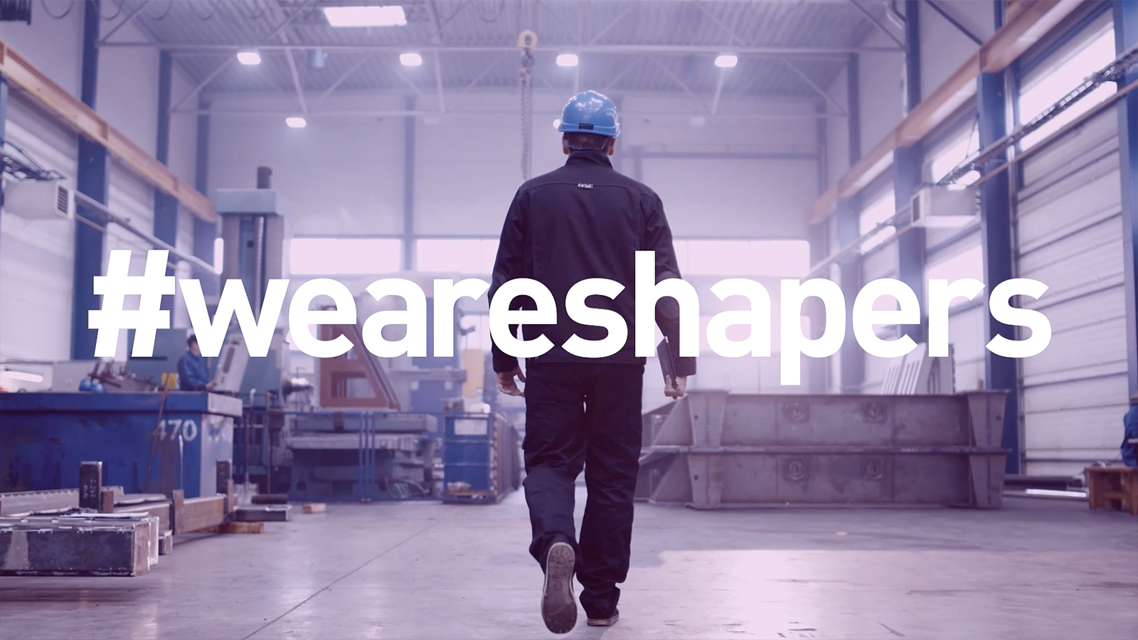

We are Shapers
We are on an exciting journey towards becoming number one in our industry. To reach the next level and be successful, we need people who have a can-do attitude, are open to change and have a strong interest in finding new solutions. And of course, passion for our customers. To improve ourselves and our business, we need people with strong motivation to always do better than yesterday and learn new things – people who shape their own future through daily challenges in an ever-changing environment.

